Ensuring the high-performance switching with Socomec’s ATyS d H

Benfeld, March 27th, 2017
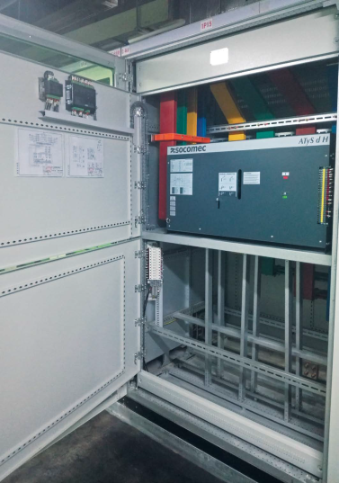
A subsidiary of China Telecom – the largest telecommunications operator in China – Dongguan Telecom is a leading national internet and mobile network service provider.
The key requirement for this Data Center facility was to ensure transfer between a 2000 kVA transformer and a 2000 kVA genset. Guaranteeing mains incoming power across the whole infrastructure, 4000 4P 380 VAC, the power supply interruption to the load is minimal during transfer. Ongoing safety and performance - and guaranteed business continuity - are vital, as is the associated protection of critical assets, infrastructure and people.
The solution was to use ATyS d H Transfer Switching Equipment from 4000 to 6300 A. which is a remote three phase transfer switch with 3 and 4 poles and integrated dual power supply.
For this project eight units of 4000 A 4P have been supplied.

Socomec’s ATyS d H Transfer Switching Equipment has been designed for use in power systems for the safe transfer of a load supply between a normal and alternative source. The ATyS d H is a Remotely operated Transfer Switching Equipment (RTSE) that can be easily used in conjunction with an ATS controller – C20/30 or C40, depending on the application – to provide automatic functionality. Power availability is safeguarded when using integrated and safe Transfer Switching Equipment. The ATyS d H includes two mechanically interlocked switches to ensure fast switching whilst providing a neutral (Off - 0) position. This ensures that the main and alternative power supplies do not overlap.

Socomec’s solutions were chosen because of the specialist support throughout the project, but also because of its expert training, business continuity and safe product maintenance.

More information on our website

ABOUT SOCOMEC |  | MORE INFORMATION
Founded in 1922, SOCOMEC is an independent, industrial group with a workforce of 3100 people spread over 27 subsidiaries in the world. Our core business – the availability, control and safety of low voltage electrical networks with increased focus on our customers’ power performance. In 2016, SOCOMEC posted a turnover of 480 M€. |  | Press contact  Virginie GUYOT  Offer Communication Manager  Tel: +33 (0)388577815  Email: virginie.press@socomec.com  www.socomec.com

