HOT PROPERTY
Behind the scenes: Socomec tech powering a super-sized shopping experience in China

Benfeld, September 18th, 2017
Socomec’s automatic transfer switching technology is powering a new super-mall in China
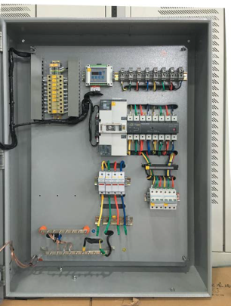
Since 1992, Linca Industrial Group has delivered pioneering projects, transforming the landscape of urban areas.
Much more than a shopping venue, one of the group’s most recent and progressive developments - the Fuzhou Lijia International Commercial Center, China - is hot property.
A 3 million square meter, 100 billion RMB project - the result is a super-sized commercial, leisure and shopping complex with 4D theatre and on-site hotel. For those who want their own slice of the real estate, exclusive apartments are even available to buy on the prestigious site.

Behind the scenes, the technology that powers the logistics centers, office buildings and critical supporting infrastructure has to work hard to keep pace – and must guarantee the availability of safe, high quality power across the entire estate.
In partnership with a local distributor, the integrated power solutions manufacturer, Socomec, has provided the Fuzhou Lijia International Commercial Center with more than 3000 of its ATyS t M Automatic Transfer Switches.
Enabling automatic transfer switching between two sources (normal – alternative) the system ensures the protection of critical assets – and people – whilst maximizing uptime for the busy commercial center.
With fast and easy integration - contact transfer time of less than 180 ms – it was possible to both minimize downtime and deliver against project budgets and timescales.
Kevin Wang, Product Support and Training Officer, Socomec comments; “The protection of critical assets – and guaranteed business continuity – were vital factors in this high profile project. Downtime is simply not an option in a development of this nature. It was also important to be able to integrate power switching and control within one solution – and that the solution was easy to integrate with the building management, fire and monitoring systems. Furthermore, because we have built a global network of expert engineering and technical resource, we are able to support the equipment locally, around the clock, and throughout the entire product lifecycle.”

Socomec’s ATyS t M are 4 pole, three-phase or single-phase, modular Automatic Transfer Switches with positive break indication. Ideal for use in low voltage power supply systems, the equipment monitors and ensures the supply to a critical system and – in the event of failure or instability – safely manages the transfer to an alternate source.

Engineered for safety, the ATyS M has a manual operating handle as standard, enabling emergency access at all times.

More information on our website

ABOUT SOCOMEC |  | MORE INFORMATION
Founded in 1922, SOCOMEC is an independent, industrial group with a workforce of 3100 people spread over 27 subsidiaries in the world. Our core business – the availability, control and safety of low voltage electrical networks with increased focus on our customers’ power performance. In 2016, SOCOMEC posted a turnover of 480 M€. |  | Press contact  Virginie GUYOT  Offer Communication Manager  Tel: +33 (0)388577815  Email: virginie.press@socomec.com  www.socomec.com

