DIRIS Q800: a groundbreaking solution in the field of network analysis

Benfeld, 3rd April 2017
The DIRIS Q800 network analyser, an extremely comprehensive and user-friendly solution, boasts an unparalleled level of quality compared to other analysers on the European market and is IEC 62586-2 Class A certified.

Reasons for investing in energy quality analysis
The electrical energy that powers a network or facility is subject to pollution or interference stemming from a wide variety of sources. This can have severe consequences for sensitive equipment connected to the network and can sometimes cause outages that adversely affect the operation of critical facilities: industrial production lines, data centers, infrastructures, healthcare centres and more generally, lighting and safety systems in public-access buildings, and others.

Continuity and optimisation of operation
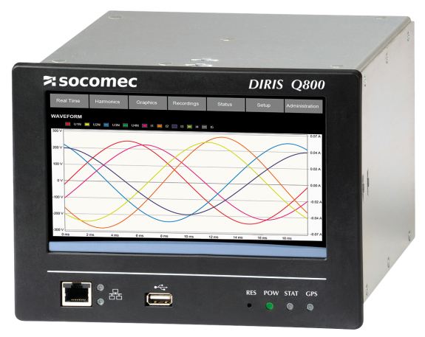
Socomec's DIRIS Q800 electrical network analyser identifies the sources of failure before they reach a critical point for the application. This way, any potential preventive maintenance operations can be performed in time to guarantee the availability of the required electric power. Interesting fact: the analyser can source the origin of the problem, whether stemming either from the power facility or the utility.

Besides anticipating power failures, the DIRIS Q800 network analyser optimises the power facility as part of an energy efficiency initiative. It analyses all the parameters that are likely to affect the availability of energy and the associated costs:
- Transient events
- Flickers
- Imbalances
- Harmonics
- Remote control signals
By also monitoring the differential current, DIRIS Q800 permanently monitors the overall insulation level of a facility.

Unique quality in Europe
The measurement features of DIRIS Q800 were developed in keeping with IEC standard 61000-4-30 Class A. DIRIS Q800 is the first device in Europe to be certified to the latest product standard IEC 62586-2 Class A, published in 2015. These standards guarantee a high level of accuracy and time synchronisation that make DIRIS Q800 a high end product. Certification of this analyser to these standards provides contractual means of verifying the quality of the delivered electrical energy.

A user-friendly solution
With a size of about 20 x 15 cm (the size of an iPad screen) and a high definition display, the colour touch screen has an easily navigable interface. The interface and display surface are similar on the device's screen and web server, which significantly improves use and toggling from one to the other.

Cutting-edge connectivity
DIRIS Q800 boasts an array of features and is also designed to suit all facilities. It features:
- Logic and analogue inputs/outputs,
- Wifi, Ethernet, RS485, USB and GPS communication ports
- SNTP, HTTP, HTTPS, FTP, Modbus TCP, Modbus RTU and PQDIF protocols.

Therefore it provides the best network analysis for all environments.

Compliance with standards
The DIRIS Q800 network analyser complies with:
- IEC standard 61000-4-30 Class A,
- IEC standard 62586-2 Class A,
- IEC standard 62053-22 and -23.

It measures and displays conformity reports to standard EN 50160, which allow for the verification of the quality of the energy provided by the utility.

Important information
- Network analyser for the prevention of quality faults and optimising the costs of electricity
- First analyser in Europe with IEC 62586-2 Class A certification
- Large colour touch screen with display identical to the web server's
- Compatible with all facilities

For further information about DIRIS Q800.

ABOUT SOCOMEC |  | MORE INFORMATION
Founded in 1922, SOCOMEC is an independent, industrial group with a workforce of 3100 people spread over 27 subsidiaries in the world. Our core business – the availability, control and safety of low voltage electrical networks with increased focus on our customers’ power performance. In 2016, SOCOMEC posted a turnover of 480 M€. |  | Press contact  Virginie GUYOT  Offer communication Manager  Tel: +33 (0)3 88 57 78 15  Email:  virginie.presse@socomec.com  www.socomec.com

