ITYS PRO: the UPS range that combines high performance and cost-effectiveness from 10 to 20 kVA

Benfeld, 22nd May 2015
Designed for server rooms, the service sector, infrastructure, the healthcare sector and light industrial applications, ITYS PRO is the latest innovative UPS solution designed and produced by Socomec.

Compact but fully equipped, easy to use and flexible, ITYS PRO simplifies each step of the project - from the design through to installation, including all maintenance operations. This ensures business continuity and reduces the total cost of ownership for the electrical infrastructure.

Cost-effective UPS solution
Electrical equipment installers and contractors require UPS solutions that are easy to order and operate. ITYS PRO greatly simplifies installation procedures and reduces the overall start-up costs. Easy to set-up and manage, it ensures fast deployment of the UPS with minimal effort and time.
Delivering top performance and reliability in a cost-effective offer, ITYS PRO guarantees full protection and a low total cost of ownership in SME business critical applications.
An innovative battery management system produces virtually zero ripple on batteries, thus considerably extending battery life.

Easy-to-adapt and feature-rich
Flexible configurations, high levels of performance and ability to operate in demanding electrical environments makes ITYS PRO the right choice for facility managers and consultants looking for easy-to-adapt and feature-rich UPS solutions.
Three different UPS configurations are available: without batteries (Type S), with batteries (Type M), and with batteries or isolation transformer (Type T). A battery cabinet completes the range, which offers the choice of flexible back-up times without increasing the footprint.
State-of-the-art technology provides high levels of performance in a very compact unit. The "online double conversion" mode with an output power factor of 0.9 provides 12% more active power compared to UPS with a power factor of 0.8. ITYS PRO also offers best-in-class online efficiency (95%) and is designed to operate in challenging electrical environments (input voltage anomalies, overload, over temperature, etc.).
With low electromagnetic emissions, ITYS PRO complies with commercial installations (IEC 62042-2 category C2).

Key facts
- VFI "online double conversion" technology
- 95% Efficiency
- Power factor: 0.9
- 3-level technology
- System flexibility and scalability guaranteed during the service life of the infrastructure

Photo
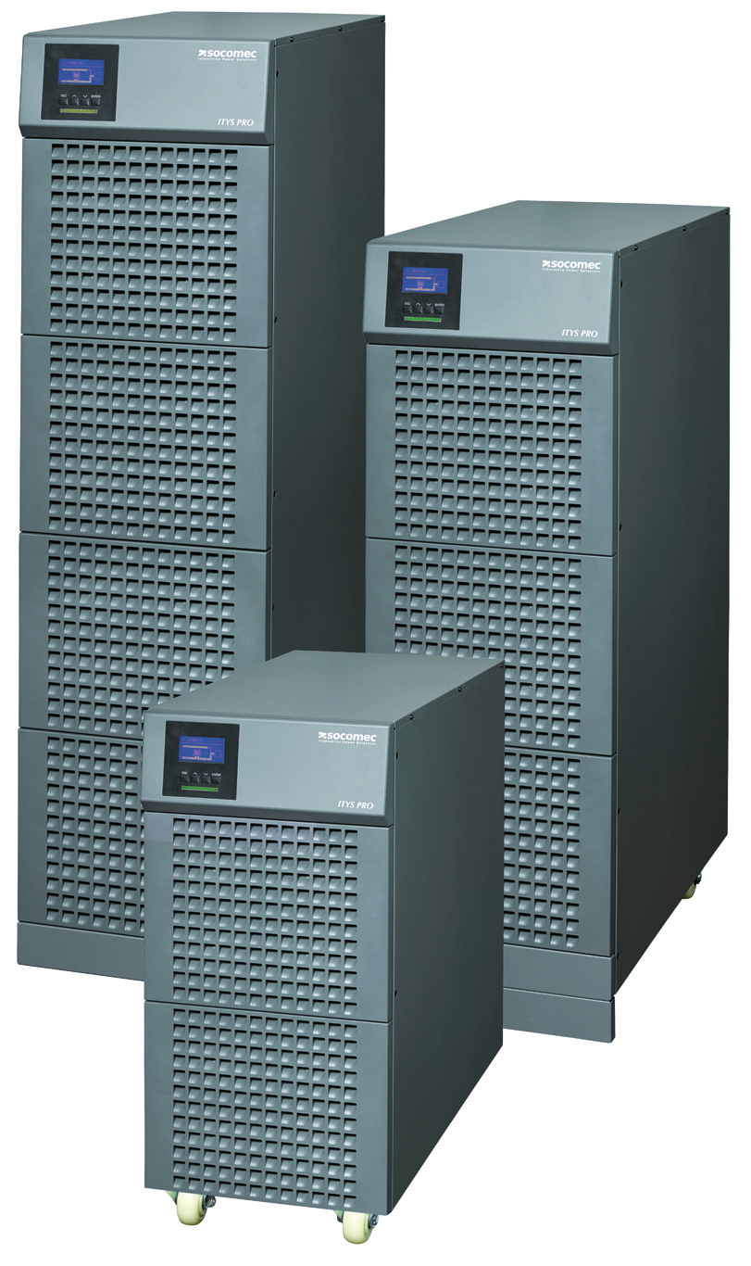

ABOUT SOCOMEC |  | FOR MORE INFORMATION
Founded in 1922, SOCOMEC is an industrial group with a workforce of over 3000 people around the world in 21 subsidiaries. Our core business: the availability, control and safety of low voltage electrical networks… with increased focus on our customers' power performance. In 2014, SOCOMEC posted turnover of 427 million euros. |  | Press contact: Virginie GUYOT  Offer Communication Manager  Tel. : +33 (0)3 88 57 78 15  E-Mail: virginie.guyot@socomec.com  www.socomec.com

