MODULYS XM
the unique new UPS that’s reliable, flexible and built to last
City, Date xx^{th}, 2023

With a proven track record in modular technology, integrated power manufacturer, Socomec, is a recognised leader in modular UPS solutions.
Socomec’s modular family is now growing with the introduction of a new medium power model – the MODULYS XM.
The new Socomec MODULYS XM is a medium power modular UPS based on 50 kW power modules; the installed power can be increased up to 600 kW, plus an extra 50 kW redundancy, all within the same footprint. As flexible as it is reliable, the MODULYS XM can be configured to order.

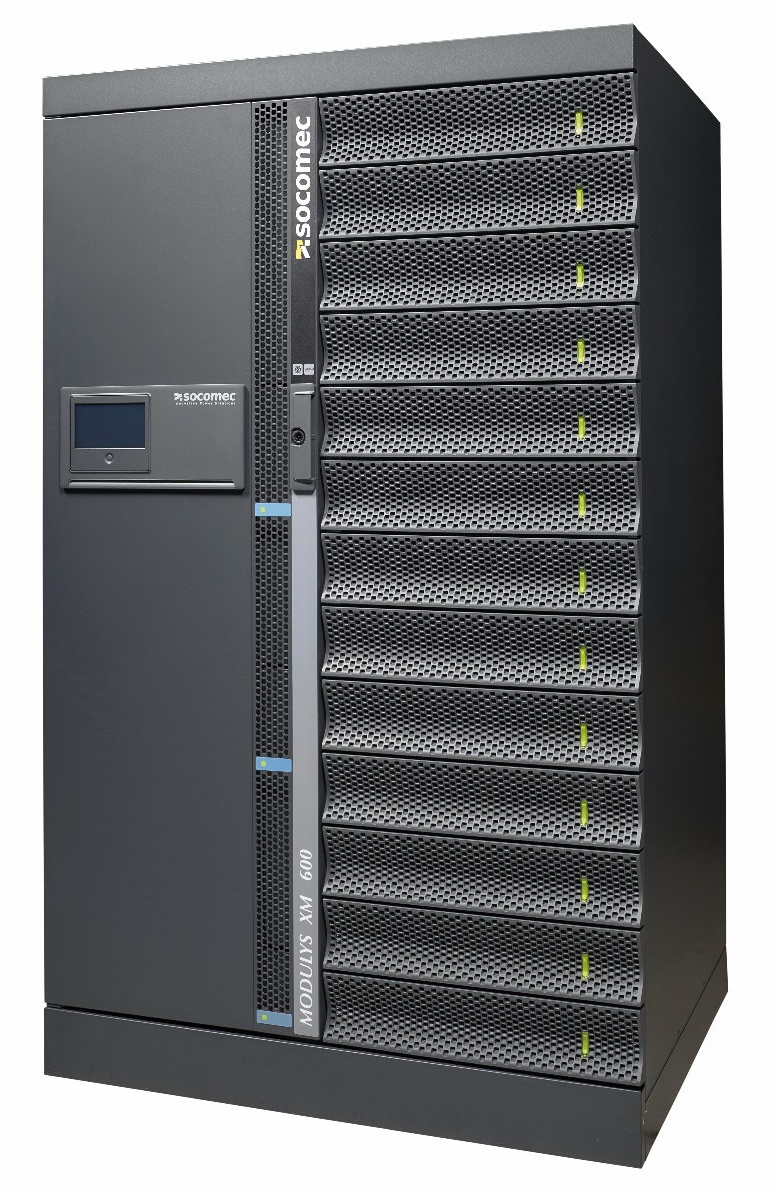 | MODULYS XM comprises a 50 kW power module and an optimised set of fully equipped systems:  - MODULYS XM, for 250 kW + 50 kW redundancy  - MODULYS XM, for 600 kW + 50 kW redundancy
Proven ultimate reliability
MODULYS XM’s 50 kW power modules have proven reliability of more than 1,000,000 hours MTBF (Mean Time Between Failures), as certified by a third party based on robust data - which is at least 4 times longer than the best market standards.
In addition, both seismic resistance and double immunity to disturbances have been certified by a third party, against the highest market standards, with MODULYS XM demonstrating the highest degree of reliability.
Change or add modules in just 2 minutes
Power modules are truly hot-swappable by on-site people and the whole process is simple and risk-free, taking just 2 minutes. This is possible thanks to self-aligning firmware, self-setting parameters and full self-testing - all of which are completely automatic and done without any human intervention.
Static bypass and all other parts are also hot swappable via front access, while the UPS is working and without any interruption.
A flexible UPS that adapts to your needs
With a set of more than 25 standardised and pre-engineered parts, the MODULYS XM can be configured on customer needs in a multitude of combinations in order to create a tailor-made solution. Moreover, with hot-swap power modules, the system’s power can be increased on demand. On-site people can scale the system by adding a module, simply by plug-in it - without any risk. Furthermore, by adding an extra bypass module, it is also possible to increase the short-circuit current withstanding, making MODULYS XM unique in the market.

Long lifetime, low impact
The design lifetime of MODULYS XM is in excess of 25 years in a Data Centre environment and in excess of 20 years in worst-case conditions, satisfying a key requirement of the circular economy, which is to keep products in circulation for longer. The lifetime has increased by 50% compared to market standards, and is proven beyond calculations and simulations, with MODULYS XM having passed demanding stress and accelerated lifetime tests.
Furthermore, the future availability of modules and all subassemblies is guaranteed for the complete lifetime of the UPS.

Connected services: a smarter way to manage your UPS
MODULYS XM is connected to the world, and to the world of its users.
Socomec’s free mobile App, SoLive, automatically reports the latest status of your the UPS, providing instant notification of any events.
Alternatively, Socomec experts can provide 24/7 monitoring and will send a technician to location if necessary, or provide a notification for absolute peace of mind.
Whit Remote troubleshooting technology, Socomec experts can connect to the UPS system, in order to run remote tests and diagnostics – all with zero transport-related carbon emissions.

A reliable, flexible and forever young UPS, MODULYS XM is the ideal solution for a range of applications. To learn more (INSERT CONTACT DETAILS / LINK?).

SOCOMEC: When energy matters |  |  | Press contact
Founded in 1922, SOCOMEC is an independent industrial group with a workforce of 3600 experts spread over 28 subsidiaries in the world. Our core business: the availability, control and safety of low voltage electrical networks serving our customers’ power performance. In 2020, SOCOMEC posted a turnover of 544,4M€. |  | Web: www.socomec.co.uk  Email: info.uk@socomec.com  LinkedIn : Socomec Group

