Socomec Li-Ion UPS technology at JSR Micro N.V.

Benfeld, 03rd April 2017
The Li-Ion Capacitor UPS – Socomec’s innovative lithium-ion capacitor-based UPS solution - protects JSR Micro N.V.’s chemical process installation and compressed air production system from frequent outages.
Power outages, lasting from a few seconds to several minutes, may cause damage, loss of production and an increase in costs for applications and processes sensitive to short duration downtime. To ensure the optimal availability and working life of the batteries, the power supply must be protected by a powerful UPS back-up storage solution with a very short recharging time, requiring low maintenance and providing constant monitoring.

JSR Micro N.V. requires protection from any possible power supply outages for a chemical process installation and a compressor providing compressed air to a chemical production installation.

As both the chemical process installation and the compressor are very sensitive to short duration power dips - of the order of seconds, but causing process interruptions, loss of production and an increase in costs - JSR Micro N.V. has chosen to protect these sensitive critical applications with Socomec’s Li-Ion Capacitor UPS. This cost-effective UPS back-up storage solution is specifically designed to protect applications requiring a back-up time lasting from a few seconds to several minutes, and to safeguard processes sensitive to frequent micro-interruptions. It ensures the maximum availability and reliability of the power supply to these applications.

The Li-Ion Capacitor UPS solution
- A Socomec Li-Ion Capacitor UPS sized for an 80-kW load system.
- A back-up energy storage system made from Lithium-Ion Capacitor (LIC) cells manufactured by the JM Energy Corporation and assembled in EAS Elettronica Endurance modules
- The system provides a back-up time of two minutes which allows for the addition of supplementary loads without altering the UPS protection.

The benefits of the Li-Ion Capacitor UPS solution
- This system generates lower heat than a standard long-term back-up UPS system using VRLA (Valve Regulated Lead Acid) batteries.
- VRLA batteries require yearly maintenance and cannot withstand short power interruptions.
- The Li-Ion Capacitor UPS solution is highly reliable, ensuring an optimal performance in all critical operating conditions, whilst only requiring extremely low maintenance.
- The Li-Ion Capacitor UPS solution’s ultra-high power density in a reduced footprint allows for the preservation of space in the production environment, where the efficient use of every square metre is important.
- The system’s ultra-fast recharge requires only a few minutes until the Lithium-Ion capacitor blocks are fully charged, ensuring maximum availability and a total protection from short power drops.
- The system can be safely installed in a standard room with no temperature, humidity or dust control, whereas VRLA batteries require special ventilation when installed in closed areas to avoid generating hydrogen.

- The embedded cell-to-cell monitoring system provides continuous monitoring to prevent unexpected failures and reduce the number of maintenance operations.
- Partial and/or frequent discharges pose no threat to the system as it is not sensitive to regular or unexpected supply failures.

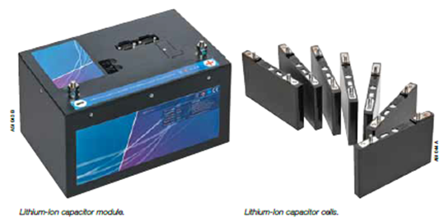

Learn more about Li-Ion Capacitor UPS.

ABOUT JSR MICRO N.V.
JSR Micro N.V., based in Leuven, Belgium, is a subsidiary of JSR Corporation, a multinational company employing approximatively 6000 people worldwide and a leading materials supplier in a variety of technology-driven markets. JSR’s global network is headquartered in Tokyo (Japan) and has factories and offices in Europe, US, China, Taiwan, Korea, Singapore and Thailand.
JSR is a research-oriented organization that pursues close collaborations with leading innovators in a number of industries that are key to the present and future welfare of human society: life-sciences, energy storage, synthetic rubbers, electronic materials, display and optical materials. ‘Innovation one-on-one’ summarizes our value proposition to our customers. Through timely and close collaboration with its partners, JSR offers its customers a competitive advantage based on leading edge technologies, consistent high quality and balanced cost of ownership. JM Energy Corporation is a fully owned subsidiary of JSR Corporation.
Contact info: JSR Micro NV: www.jsrmicro.be / energy@jsrmicro.be

ABOUT SOCOMEC |  | MORE INFORMATION
Founded in 1922, SOCOMEC is an independent, industrial group with a workforce of 3100 people spread over 27 subsidiaries in the world. Our core business – the availability, control and safety of low voltage electrical networks with increased focus on our customers’ power performance. In 2016, SOCOMEC posted a turnover of 480 M€.  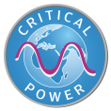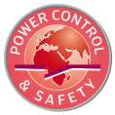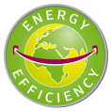 |  | Press contact  Virginie GUYOT  Offer Communication Manager  Tel: +33 (0)3 88 57 78 15  Email: virginie.presse@socomec.com  www.socomec.com

