Secure power supplies and energy efficiency: a choice of offerings for medical facilities

Benfeld, 18 June 2015

With a strong international presence and expertise in power control and safety for equipment and persons, Socomec offers effective support to medical facilities for improving energy management or extending their electrical infrastructure. It’s a product and solution offering that really makes the difference...

As a key player in providing power control and energy performance solutions for medical facilities, Socomec knows how to address the main issues faced by such establishments:
Electrical infrastructure
- securing power supplies in low and medium voltage substations;
- providing a secure and reliable power supply for all buildings;
- providing a power supply that is adapted to the level of criticality of premises.
IT infrastructure
- ensuring the protection and availability of the IT systems;
- ensuring the availability and protection of patient data and hospital communication systems.
Medical premises
- ensuring the continuity of the power supply in medical premises,
- ensuring patient safety via specific power distribution (hospital isolated power system)
Medical imaging
- anticipating service continuity for MRI and X-ray machines, CT scanners, etc.
Monitoring of buildings
- controlling building energy costs;
- monitoring critical power circuits;
- ensuring power circuits of security/safety systems.

With more than 370 Socomec experts supported by 175 engineers and technicians around the world, the company is always in close proximity to its customers and is on-hand to provide support throughout the service life of the solutions that have been implemented: pre-project phase, engineering, specific solutions development, installation and commissioning, curative and preventive maintenance, end of operating life and renewal of equipment.
Adapted responses
Whatever the problem, Socomec can be counted on to provide truly appropriate solutions that are widely recognized by medical facility operators:

- Reliable solutions for a secur electrical infrastructure

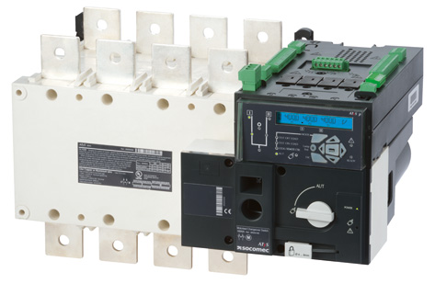
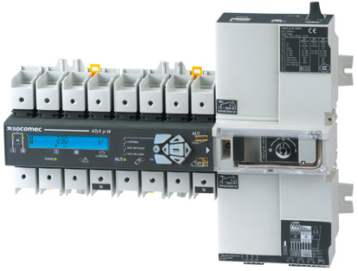
Whatever their location in the electrical architecture, Socomec’s transfer switches ensure reliable and secure power supplies. Their function is to assure the on-load transfer of two power sources in remote, automatic or manual mode (for emergency or maintenance operations). Now available in power ratings of 40 to 6300 A, these switches can be installed both at the level of the installations incomers ((in the LV switch panel) and in the section panels. In this way they provide a power supply adapted to the criticality of the loads, such as air handling units, air-conditioning, security panels, technical facilities, etc.
Assembled in dedicated cabinets for an even smaller footprint, Socomec’s transfer switches can be installed in close proximity to the loads. Preventive maintenance or inspection is therefore greatly facilitated and operator safety is maintained against accidental start-up of machines.
Finally, the Socomec “ATS Bypass” allows maintenance, test or inspection procedures to be carried out at any moment on the transfer switch without any interruption to the downstream operating loads.

- Customized “zero outage” power supply for the IT infrastructure
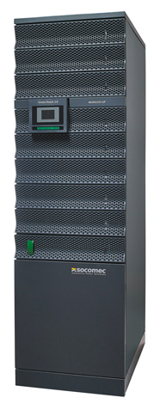
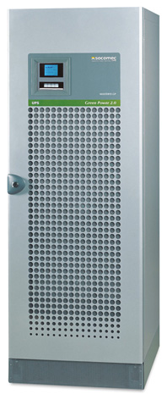
The availability of a reliable electrical power supply is vital to ensure the continuity of care. Having a secure and available power supply is vital for ensuring the provision of patient care. All the equipment that directly or indirectly affects the safety of patients or personnel such as IT servers, internal communication networks, workstations, electronic medical devices etc., cannot tolerate any power outages whatsoever.
Thanks to its wide range of single unit and modular UPS, Socomec can offer highly adapted solutions for ensuring service continuity in medical facilities.
Whatever the need, Socomec is on-hand to determine the best solution in terms of flexibility, scalability, redundancy, investment, footprint and operating costs, etc.

- A dedicated solution to ensure the continuity of the power supply to medical premises
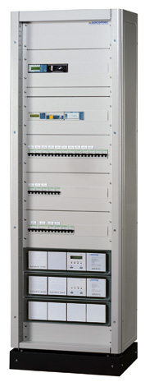
The power supply of medical premises is paramount. In such areas any electrical failure can lead to critical situations.
Socomec’s complete and compact “Medical IT power distribution cabinet” fully meets the specific requirements of medical facilities. Its compliance with the NFC15-211 operating standard covering installations in premises for medical use and with the HD60364-7-710 Harmonization Document is the guarantee of reliability and safety for both patients and personnel.

- Certified solutions that ensure the availability of medical imaging equipment

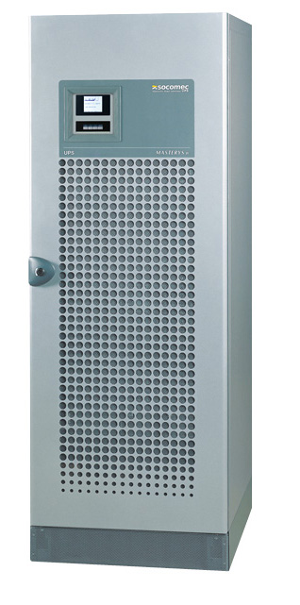
The power supply of medical imaging equipment such as MRI, angiography and CT scanners is highly demanding: high inrush current, pulse streams, etc. With a specialist know-how developed in partnership with Philips Medical, Socomec meets these exacting requirements with its dedicated UPS solutions to ensure equipment availability and to limit their overall impact on the electrical installation.

- And for optimizing energy costs…
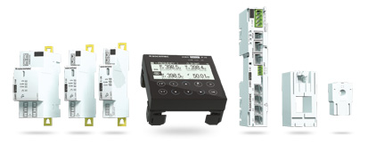
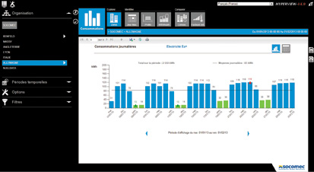

In 2014, Socomec launched a new range of “plug & play”; multi-circuit measurement and monitoring equipment - the DIRIS Digiware system.
DIRIS Digiware measures electrical parameters and monitors the quality of the power supply. Thanks to its great flexibility, this innovative solution can easily be integrated in new or retrofit installations. The “plug & play” feature (with simplified wiring and auto-configuration of parameters) means that implementation time is significantly reduced.
Using DIRIS Digiware in conjunction with Socomec’s VERTELIS WEBVIEW and HYPERVIEW energy monitoring software, the facility operator can closely monitor and manage their installation: analysis and tracking of consumer excesses (fluids, electricity), patterns of consumer use, easy identification of ways to make energy savings, and encouraging a more cost-conscious attitude among personnel.
The complete DIRIS Digiware solution and VERTELIS WEBVIEW/HYPERVIEW software with its high modularity offers customers the opportunity to commit to an energy performance process with a minimum/limited amount of configuration (monitoring several key points of the installation) and to run the solution in full autonomy.

Customers who have implemented Socomec solutions

- The Medical IT cabinet for the Sarreguemines Hospital
“To secure the power supply of the eight operating theatres, our engineering consultants decided on a dedicated power supply for each room”, explains Jean-Marie BICHLER, Chief Hospital Engineer at Sarreguemines Hospital (268 beds). “Socomec was selected to equip every operating theatre with a medical IT distribution cabinet comprising a transfer switch at the level of section incomers, a modular UPS, an IMD and a medical IT transformer. The products integrated in this cabinet are robust and reliable. Carrying out maintenance procedures on one operating theatre does not compromise the availability of the others.”

- The solutions for medical imaging equipment at the Rennes University Hospital
“We were looking for the best technical and economic compromise to secure the power supply to five of our radiology rooms”, explains Loïc BARDOU, Maintenance and Electrical Operations Manager. “With Socomec, we opted for a 300 kVA DELPHYS MX UPS so as to aggregate this protective solution for all the five rooms and hence optimize the investment costs. Combining a flywheel with the batteries also meant the system could absorb the peak currents you often get when running medical imaging equipment. This sort of configuration also helps prevent premature ageing of the batteries. Combining the flywheel with the batteries will also help us keep our maintenance and running costs down. When the time came to make the final selection, we chose Socomec’s offer for their engineering expertise, advice, support and guidance in implementing this innovative and strategic project for the hospital’s radiology facilities.”

- Energy efficiency solutions for the Cork University Hospital (Ireland)
With 1000 beds, the Cork University Hospital is the biggest teaching hospital in Ireland. To improve energy efficiency, Cork UH opted for a solution for managing 50 DIRIS A60 and DIRIS A40 measuring points with associated VERTELIS HYPERVIEW software.

ABOUT SOCOMEC |  | FOR MORE INFORMATION
Founded in 1922, SOCOMEC is an industrial group with a workforce of over 3000 people around the world in 21 subsidiaries. Our core business: the availability, control and safety of low voltage electrical networks… with increased focus on our customers' power performance. In 2014, SOCOMEC posted turnover of 428 million euros. |  | Contact : Hervé MAGONI  Market Application Engineer  Tél. : +33 (0)388574955  E-mail : herve.magoni@socomec.com  www.socomec.com

