Driving innovation in the clean energy sector – New outdoor C&I energy storage system launch
Benfeld, December 20, 2021

The battery industry is on the uptake for many years now and this affects all businesses segments (residential, commercial and industrial buildings and utility scale) in which energy storage is deployed.

The situation is specific in the Commercial & industrial sector: there the storage systems are assets, investments whose returns are measured in ROI and NPV. Strong returns require robust and reliable equipment backed by equally robust warranties.
This is the context in which Socomec announced its new system: SUNSYS HES L- a new range of Energy Storage Systems optimized for the uniquely demanding requirements of the Commercial and Industrial market, combining cutting-edge technology with industry-leading flexible performance guarantees.

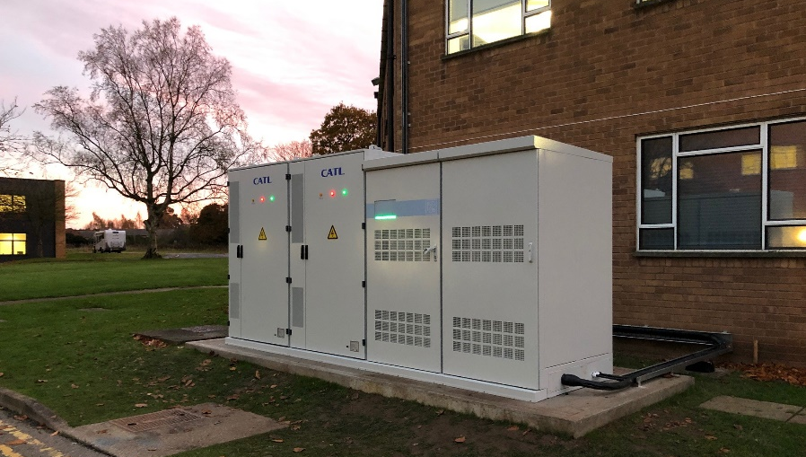  . | Safety is always Socomec’s top priority, so SUNSYS HES L is tested and certified to the latest and most stringent certification standards, including the additional requirements for the most demanding markets like California. SUNSYS HES L is available with both IEC and UL certifications, for installation around the globe.

Founded in 1922, Socomec is a leading manufacturer of electrical equipment such as conversion, switching, monitoring and measurement.
In 2010 Socomec introduced their first generation of energy storage systems. Initially focused on pre-assembled microgrids for remote locations, Socomec soon expanded into the rapidly growing American market for on-grid energy storage. SUNSYS HES L combines Socomec’s experience in both on-grid and microgrid technologies, to create a range of native-outdoor energy storage systems well matched to today’s requirements for on-grid systems with microgrid capabilities.
The SUNSYS HES L embodies “Variety without Complexity”, using a small number of modular components installed in parallel to create dozens of kVA/kWh combinations. There are two main cabinets in the system: battery cabinets and converter cabinets. Additional cabinets make it possible to increase the energy (SUNSYS DC-Cab L) or to develop tailor-made services for On-grid and Off-grid applications (SUNSYS AC-Cab L).
SOCOMEC has selected CATL (Contemporary Amperex Technology Co. Limited) as the ideal battery partner for SUNSYS HES L. The Lithium Iron Phosphate (LFP) CATL EnerOne delivers industry-leading battery safety and performance, in a modular, space-efficient enclosure. The 186kWh battery cabinets arrive fully assembled to minimize installation work onsite.
For added flexibility, the converter cabinets may be configured with from one to six 50kVA power conversion modules, for 50kVA up to 300kVA per cabinet. Two converter cabinets may be combined for larger installations. Inner parts of the cabinet integrate the Battery Management System, but above all the brain of the system, a smart automation box allowing storage functions to be stacked in order to maximize savings and reduce the return of investment.
Every SUNSYS HES L includes a connection kit with all the necessary parts and cables to connect the cabinets together to enable a fast and error-free installation.
Socomec understands that service and support are as important as the hardware, so they keep experienced energy storage service teams on staff, in both Europe and North America. These teams provide design services for customized microgrids, as well as commissioning, preventive and corrective maintenances to keep SUNSYS HES L operating at peak performance for the life of the system.
Discover the new outdoor energy storage system SUNSYS HES L here.

SOCOMEC: When energy matters |  | Press contact
Founded in 1922, SOCOMEC is an independent industrial group with a workforce of 3600 experts spread over 28 subsidiaries in the world. Our core business: the availability, control and safety of low voltage electrical networks serving our customers’ power performance. In 2020, SOCOMEC posted a turnover of 544,4M€.  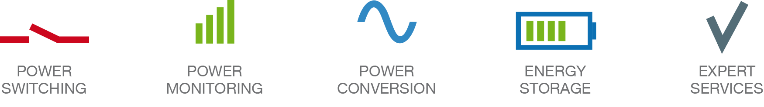 |  | Elodie HESTIN  Product Lina Marketing Manager  elodie.hestin@socomec.com  www.socomec.co.uk

