Socomec unveils new outdoor energy storage system dedicated to high power applications

Munich, June 16, 2023
Following Socomec’s successful introduction of the SUNSYS HES L, a native outdoor energy storage system ranging from 100 kVA / 186 kWh to 600 kVA / 1674 kWh, the specialist in source switching, energy conversion and measurement is now launching a higher power version.
Socomec’s new SUNSYS HES XXL offers a power range from 1 MVA / 1 MWh to 6 MVA / 20 MWh per system with the ability to achieve higher power when installed in parallel. This is particularly suitable for storage systems installed in co-location sites with renewable energy production or for use with grid support services.
With this new offering, Socomec aims to deliver projects of several tens of MW and address the needs of the Front Of The Meter (FTM) market, which constitutes a significant and rapidly growing share of storage projects worldwide.
SUNSYS HES XXL: a wide range of scalable systems – made simple
Thanks to its design, SUNSYS HES XXL offers a high degree of configurability. This modular storage system is based on:
- Two standard cabinets: a conversion cabinet (C-Cab) and a battery cabinet (B-Cab).
- A DC distribution cabinet for systems with more than 8 battery racks.
- As well as a "custom-designed" control cabinet, customisable on a case-by-case basis to meet the requirements of every installation.

This flexibility means that the solution can be tailored to most grid storage applications such as the optimisation of renewable energy integration, frequency regulation and backup.

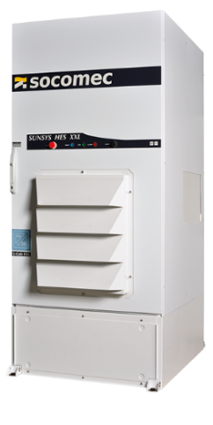 | 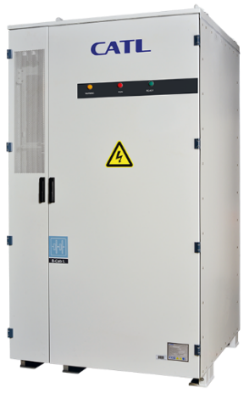 | 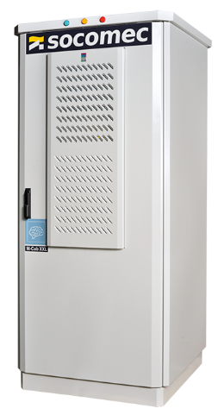 | 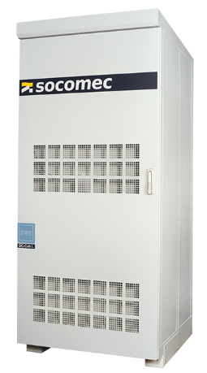
C-Cab XXL - Converter Cabinet | B-Cab XXL - Battery Cabinet | M-Cab XXL - Master Cabinet | DC-Cab XXL – DC Cabinet
- > Bidirectional power converter  - > 1.5 MVA / cabinet  - > Hybrid liquid / air cooling system  - > On and off-grid operation  - > AC/DC distribution and protection | - > Lithium ion - LFP technology  - > 372 kWh / rack  - > Liquid cooling thermal management  - > Integrated fire safety detection and extinction system | - > ESS control cabinet  > Integrated battery management system  > Devices for remote management  - > Auxiliary power supply  > PLC for automation functions and external EMS connection  > Battery data logging | > DC connections  > More than 8 B-Cab XXL per system

A focus on safety
This fully integrated system is thoroughly tested and certified, including to UL 9540, an American safety standard dedicated to energy storage systems which provides a true guarantee of safety for users.
Also, as with SUNSYS HES L, this new offering consists of a CATL EnerOne battery cooled by liquid, using LFP (Lithium Iron Phosphate) technology, capable of withstanding thermal runaway and compliant with the UL 9540A standard.
Furthermore, the cabinet also incorporates an integrated fire detection and extinguishing system for enhanced safety.
Expert services for optimised storage asset management
The SUNSYS HES XXL offering is accompanied by a complete range of services led by a team of experts. The comprehensive services include pre-sales assistance, including requirement analysis, technical pre-project design and solution evaluation. Complete solution design support and project fulfilment services are available through co-engineering with the client, alongside testing and commissioning support, operation and maintenance services.

Preventive maintenance contracts and warranty extensions are available to ensure the reliability and performance of the system, as well as to optimise its lifespan.

The daily management of the system can be further simplified by connecting it to the cloud, providing 24/7 operator monitoring through the SoLive mobile application and indicator tracking via a customised dashboard.

SOCOMEC: When energy matters |  | Press contact
Founded in 1922, SOCOMEC is an independent industrial group with a workforce of 3600 experts spread over 28 subsidiaries in the world. Our core business: the availability, control and safety of low voltage electrical networks serving our customers’ power performance. In 2018, SOCOMEC posted a turnover of 537M€. |  | Firstname Lastname  Function  Phone number  Mobile Number  xxxxxxxx@socomec.com  www.socomec.co.uk

